COMP5327 Wireless Networking and Mobile Computing

Assignment 2

Topic:

Developing school’s computer lab reservation app for iOS by Python with Kivy framework

Student Number: 21000018G

Student Name: Li Yat long

Table of Contents

1. Introduction 3

2. System Design 3

2.1 ER diagram 10

2.2 Implementation 11

**2.2.1 Creating Xcode Project** 14

3. User Manual 17

3.1 Log In 17

3.2 New Reservation 19

3.3 Reservation Record and Cancel Reservation 20

3.4 Cancelled Reservation Record 22

3.5 Log Out 22

4. Testing 23

4.1 Test Plan 23

4.2 Test Cases 24

5. Limitation and Further Development 32

6. Program Files 34

7. Conclusion 35

References 36

# **Introduction**

The popularity of mobile applications has increased significantly in the last two decades due to the introduction of smartphones and wireless communication, allowing user to work, transferring information, or even entertaining themselves anytime and anywhere. A few types of mobile computing models including mobile client server model, mobile peer-to-peer model and mobile agent model have been established to adapt the needs of different applications.

In this assignment, the client server model was introduced to build a school’s computer lab reservation app for iOS by Python and Kivy library, offering a convenient tool for students to reserve the place and manage their appointment easily.

# **System Design**

The whole reservation system includes three parts: the reservation app, the server-side program and a database connected to the server-side program.

The reservation app is the place where users interacts with the system. By installing the app on the smartphone, users can check the available time slots of the computer lab, make reservations, check the reservation record, and cancel their reservations. It connects to the server-side program through internet connection in during user’s identity authentication, time slots vacancy checking and latest reservation record uploading. User can access their reservation record in the app locally once they have logged in and loaded the history information to the app before disconnected from the Internet.

On the other hand, the database which connects the server-side program stores and manage all the user’s information, time slot information and the reservation record in a centralized environment, ensuring the integrity of data stored and maintaining the security of data while ensuring the user can access the up-to-date information.

The details of how these three parts interacted are shown in the flow chart below.

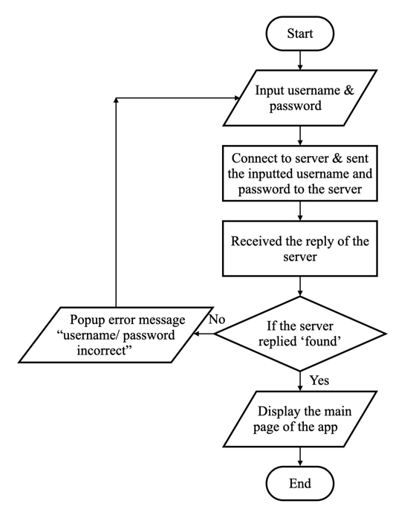

Fig. 1. Flowchart of log in function (reservation app)

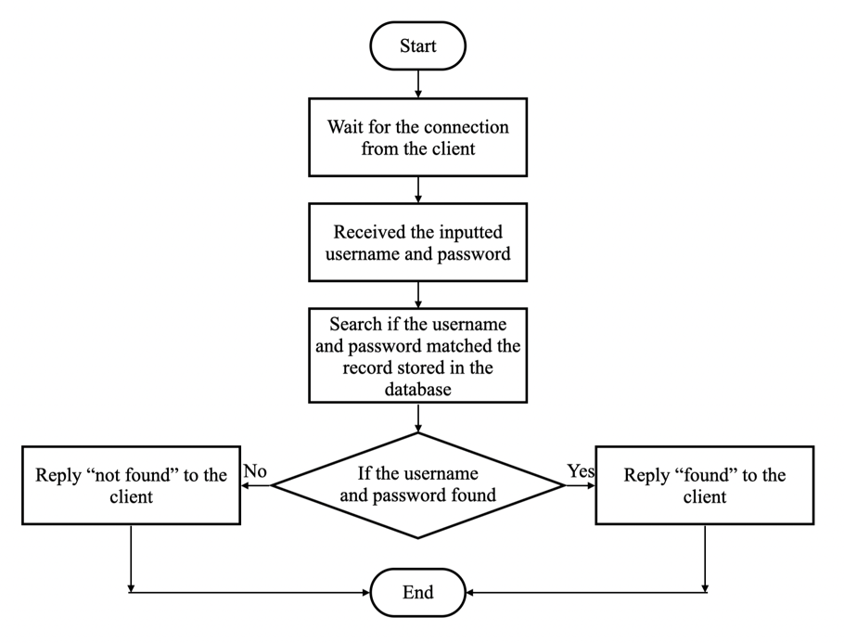

Fig. 2. Flowchart of log in function (server-side program)

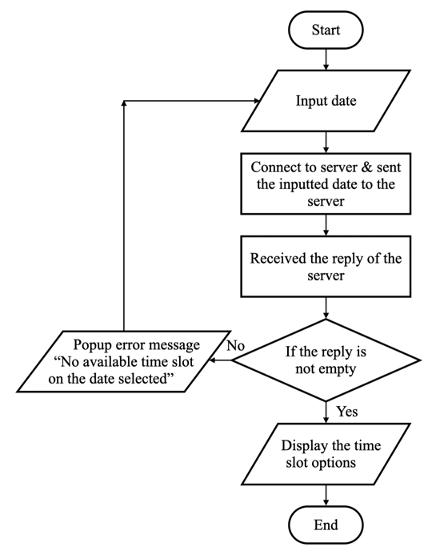

Fig. 3. Flowchart of select reservation time slot function (reservation app)

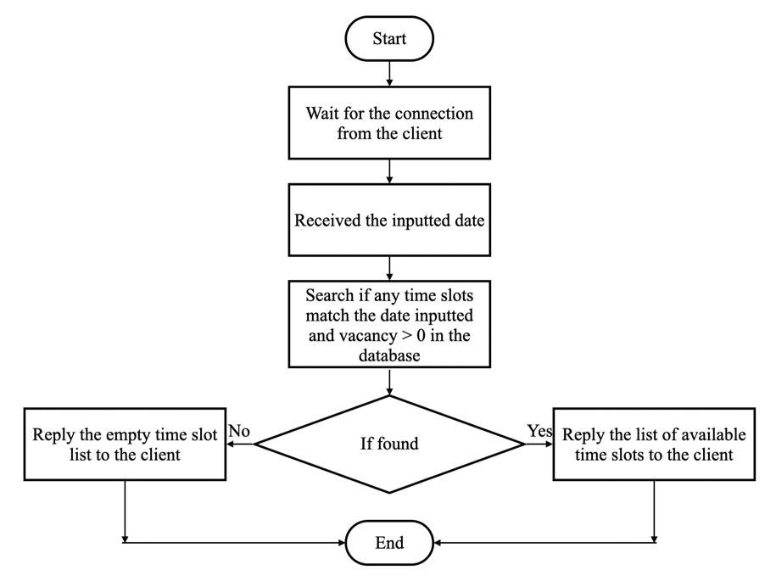

Fig. 4. Flowchart of select reservation time slot function (server-side program)

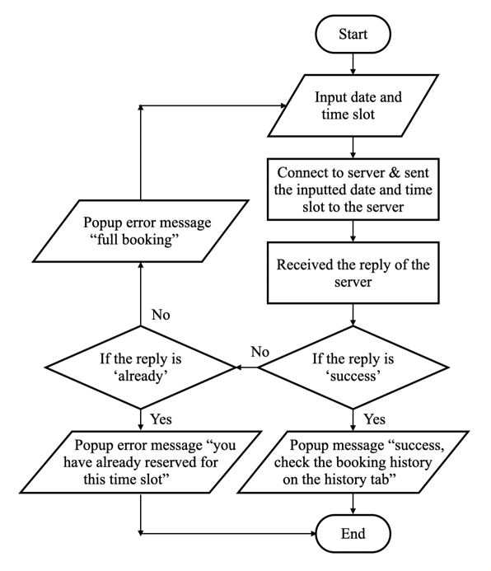

Fig. 5. Flowchart of apply reservation function (reservation app)

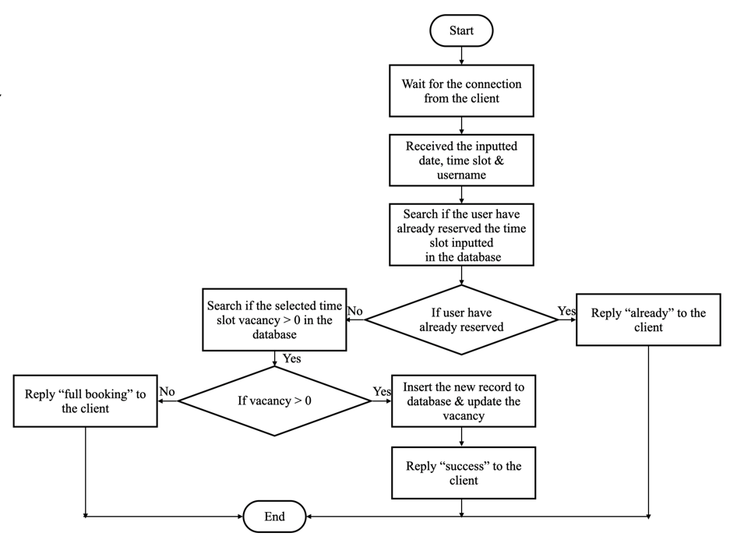

Fig. 6. Flowchart of apply reservation function (server-side program)

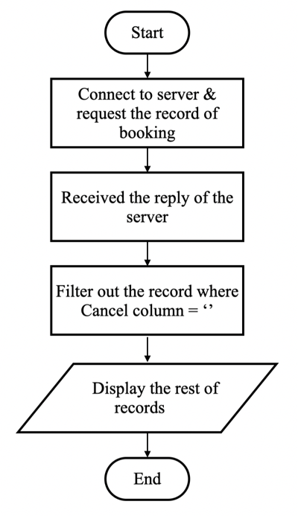

Fig. 7. Flowchart of view reservation function (reservation app)

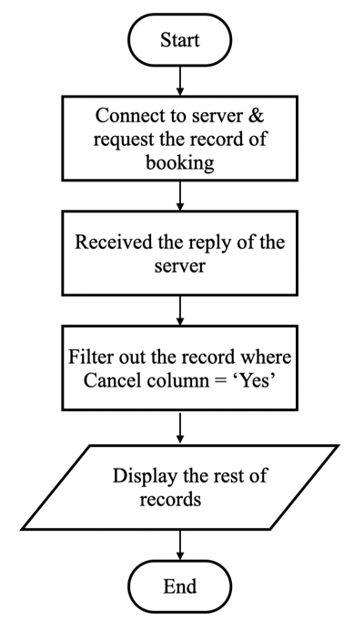

Fig. 8. Flowchart of view cancelled reservation function (reservation app)

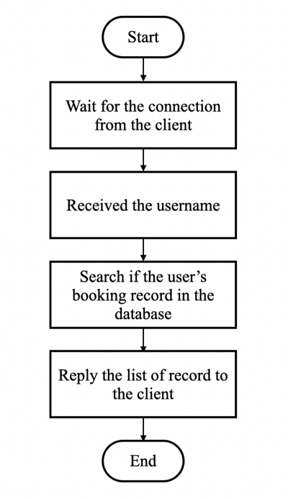

Fig. 9. Flowchart of view (cancelled) reservation function (server-side program)

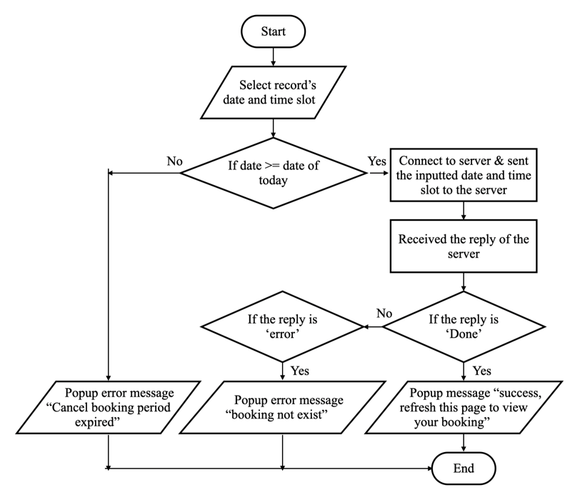

Fig. 10. Flowchart cancel reservation function (reservation app)

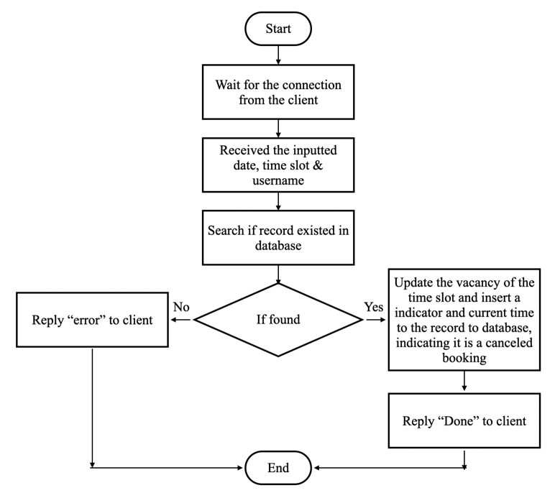

Fig. 11. Flowchart of cancel reservation function (server-side program)

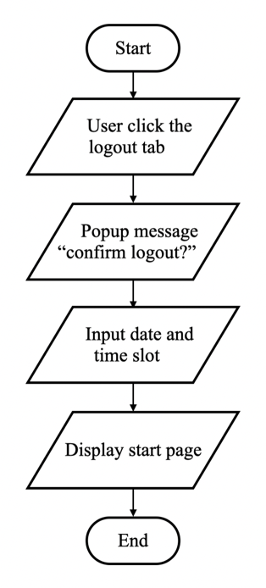

Fig. 12. Flowchart log out function (reservation app)

## **2.1 ER diagram**

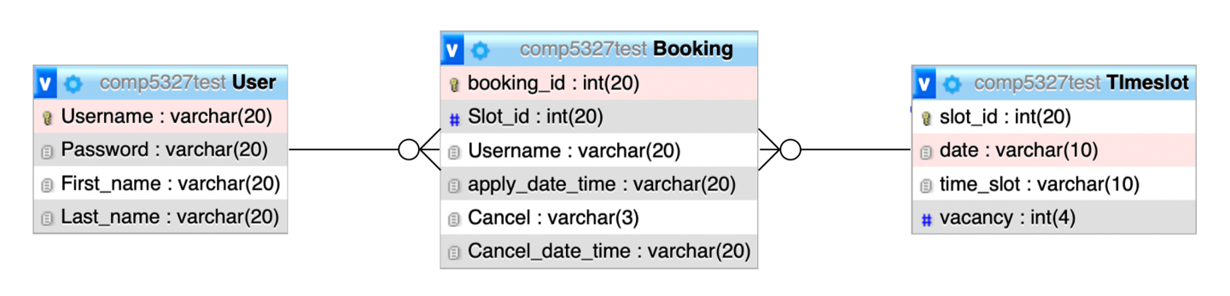

Fig. 13. ER diagram of all tables in database

As shown on Fig 13, 3 tables were introduced to the database, storing all records of user’s information, time slot and booking. The details of each table are listed below.

User Table:

Username (primary key) ­– unique ID to identify each student

Password – password of each student to log in the app

First_name – first name of each student

Last_name – last name of each student

Timeslot Table:

slot_id (primary key) ­– unique ID to identify each time slot

date – date of each time slot

time_slot – time of each time slot

vacancy – vacancy of each time slot

Booking Table

booking_id (primary key) – unique ID to identify each reservation

Slot_id (foreign key) – unique ID to identify each time slot

Username (foreign key) – unique ID to identify each student

apply_date_time ­– date and time of applying reservation

Cancel – indicator of whether the appointment have been cancelled

Cancel_date_time ­– date and time of cancelling reservation

## **2.2 Implementation**

The software and tools listed below were used for the development of both the reservation app and the server-side program.

Software and tools used for developing the two programs:

* Python 3.9
  + Some key packages/ framework:
    - Kivy 2.1.0rc1
    - Pillow 9.0.1
    - PyMySQL 1.02
    - kivymd 0.104.2
    - pyngrok 5.1.0
    - urlib3 1.26.8
  + The full list of installed packages/ framework can be referred to Fig. 14 and Fig. 15.
* Xampp 7.4.25
  + PhpMyAdmin
* PyCharm 2021.2.4
* ngrok

Software and tools used for converting the reservation app python file to iOS app in macOS environment:

* Homebrew 3.4.0
* autoconf 2.71
* kivy-ios
* Cython 0.29.28
* Xcode 13.2.1

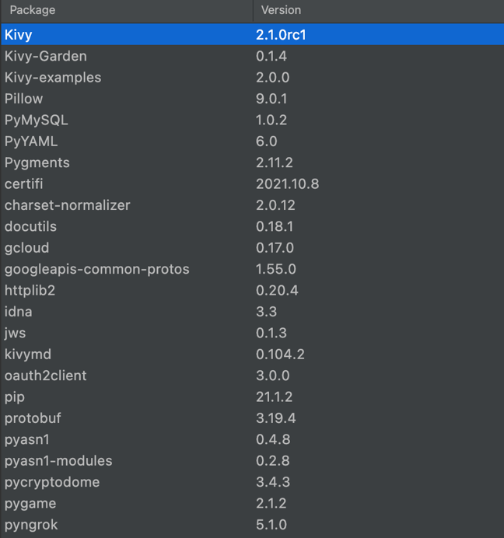

Fig. 14. Full list of python packages/ framework installed (part 1)

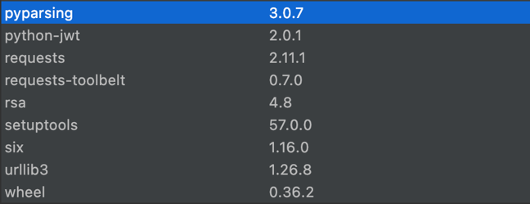

Fig. 15. Full list of python packages/ framework installed (part 2)

Python was chosen as the programming language to build both reservation app and server-side program due to its simplicity and popularity. In order to allow the Python coded reservation app runs on iOS, the free open source Kivy framework was applied, which allow Python code run on multiple platforms including Windows, macOS, Android, iOS and Raspberry Pi while offering native touch input and modern graphics powered by OpenGL ES 2. [1] This flexibility allows the reservation app to be ported to Android which is another common mobile operating system besides iOS easily with no modification on the code in the future. In Addition to Kivy, KivyMD library was also implemented, which offers Google’s Material Design style widget, producing a modern user interface on the app [2].

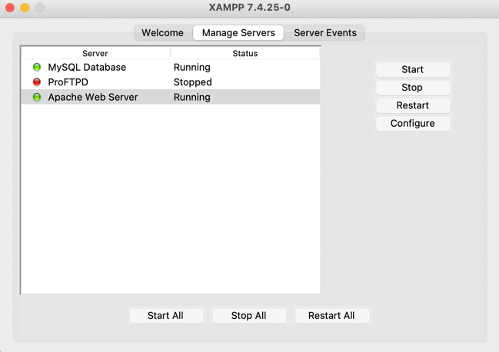

Fig. 16. Xampp interface

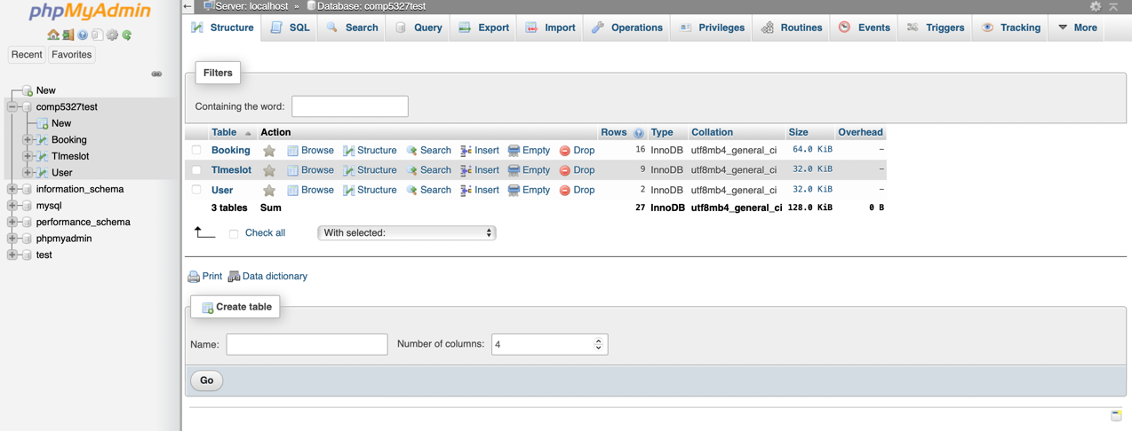

Fig. 17. phpMyAdmin interface

Xampp which is a free apache web server and PHP development environment was introduced to hosting the database (phpMyAdmin) of the system locally. [3]

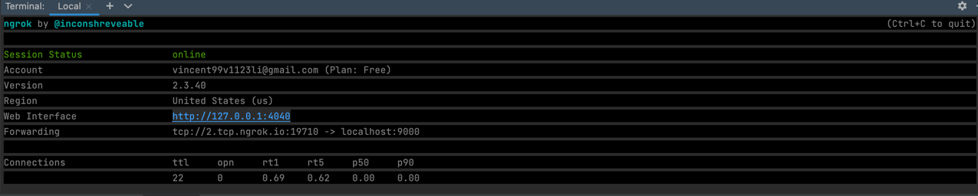

Fig. 18. Interface of ngrok running on terminal

Ngrok connects the localhost python server-side program to the ngrok cloud service by simply type “ngrok tcp ‘localhost port number’” on the terminal, offering a public TCP address to allow the reservation app to communicate with the server through Internet.

[4][5]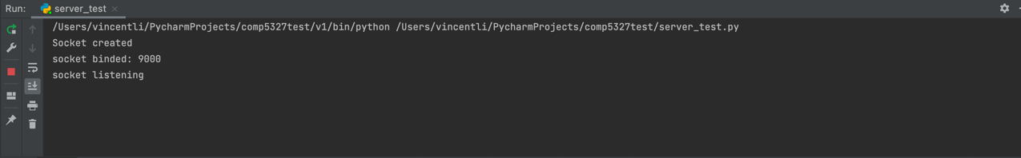

Fig. 19. Interface indicating the server-side program is running

By activating the MySQL Database and Apache Web Server on Xampp in Fig.17, the ngrok TCP tunnel in Fig. 18 and the Python server-side program in Fig. 19, the reservation app is ready to receive request from the reservation app.

### **2.2.1 Creating Xcode Project**

Xcode project are required to be created in order to run the app on iOS environment. An official tutorial offered by Kivy listed detailed instructions on how to create the package for iOS in macOS environment.

Firstly, Autoconf which produce shell scripts to configure software source code automatically for UNIX-like system and Cython which adds C extensions supports to Python, should be installed. [6]-[8]

After that, the kivy-ios toolchain which includes all libraries required to build the Xcode project and allow the app run on iOS should be downloaded from Git Hub.

[8]-[10]

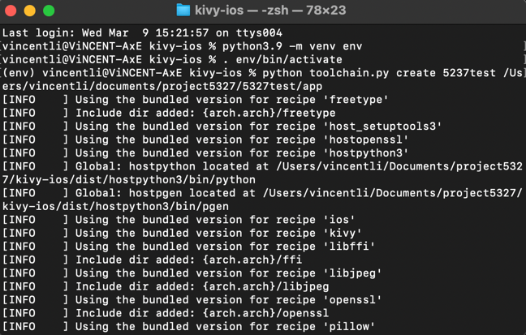

Fig. 20. Command inputted in terminal to create Xcode project

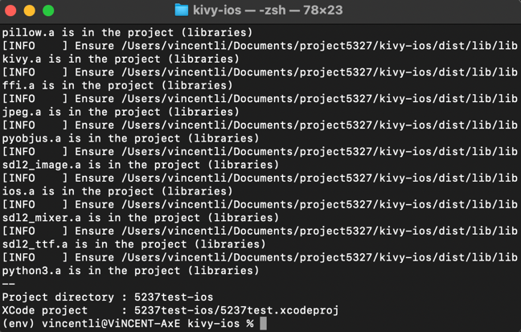

Fig. 21. Xcode project successfully created

Finally, the Xcode project can be created by typing the command on the terminal similar to Fig. 20.

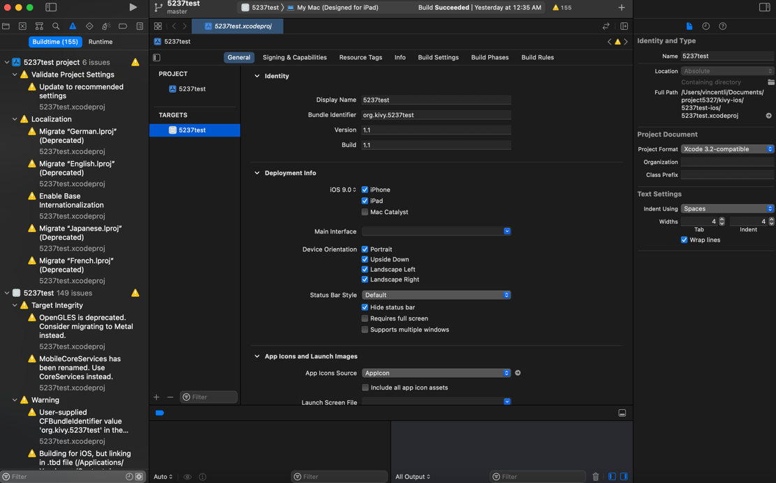

Fig. 21. Xcode interface

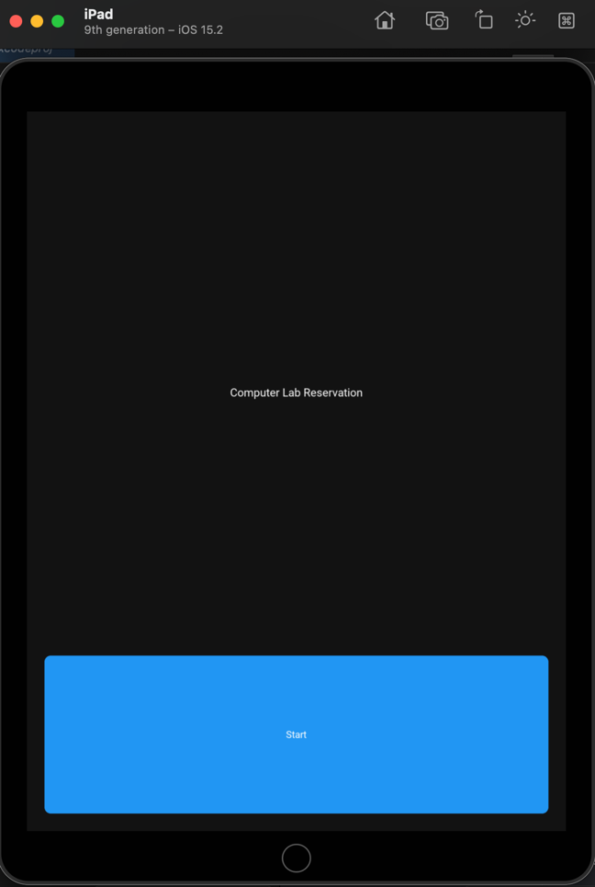

Fig. 22. Reservation app running on iOS simulator

Once the Xcode project has been successfully created, the app can be tested on iOS simulator similar to Fig 22 or downloaded to iPhone or iPad. The app can also published to the Apple App Store globally in the future by enrolling the Apple Developer Program, allowing everyone to download the app to their own device.

# **User Manual**

## **3.1 Log In**

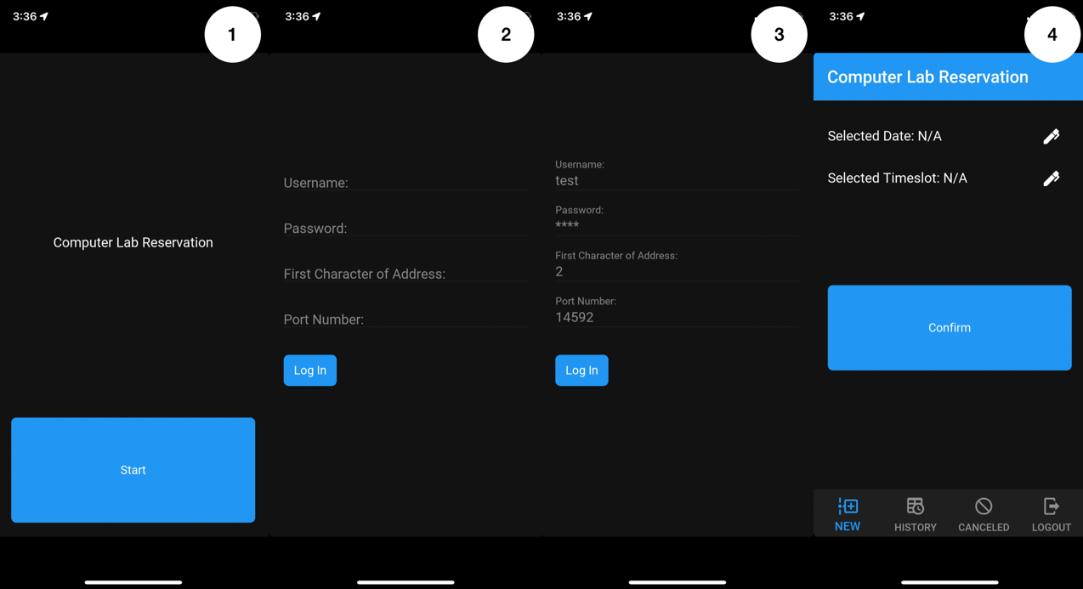

Fig. 23. Log in process of the reservation app

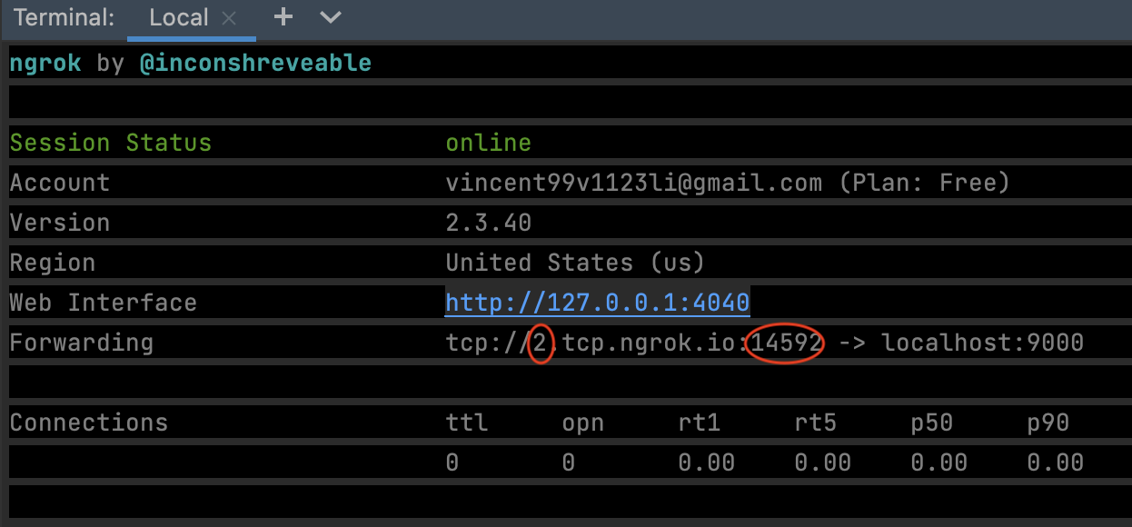

Fig. 24. Terminal screen when connecting to ngrok

The above Fig 23 shows the process of how users can login the app, which requires them to input 4 items including username, password same as the data in database and the first character of the TCP URL and the port number. Currently, the ngrok free account is being used, which do not reserve a fixed TCP channel to forward the request to our localhost server-side program. Every time the connection to ngrok is terminated and reconnected, ngrok provides a new TCP URL with changes in the first character and the port number, which is why users currently need to input this information on their own for connecting the server. This problem could be solved in the future by running the server-side program in a dedicated server with fixed TCP channel and therefore no need for user to input this information.

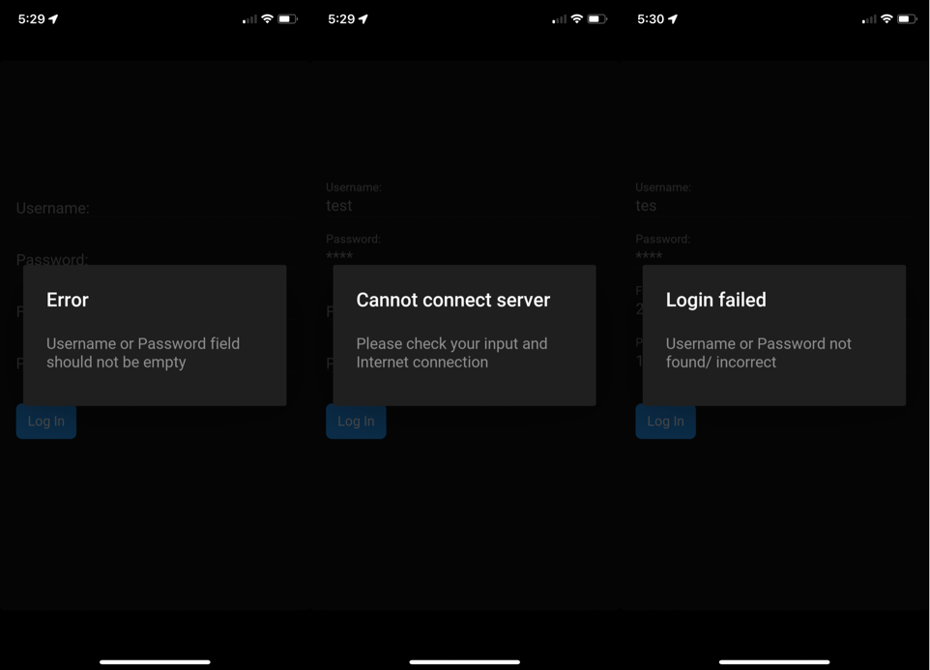

Fig. 25. Error messages of log in page

The above error messages will appear if users do not fill in the username or password, the first character of the TCP URL and the port number or the username or password do not match the record stored in the database.

## **3.2 New Reservation**

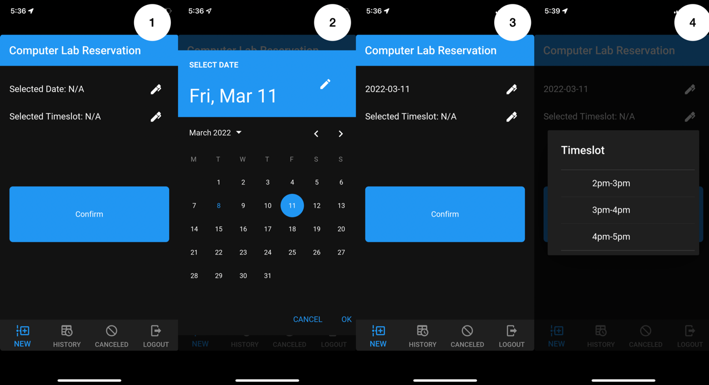

Fig. 26. Making new reservation process (part 1)

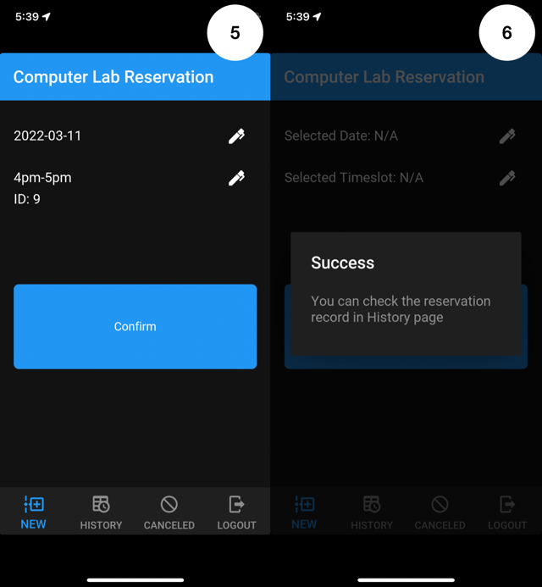

Fig. 27. Making new reservation process (part 2)

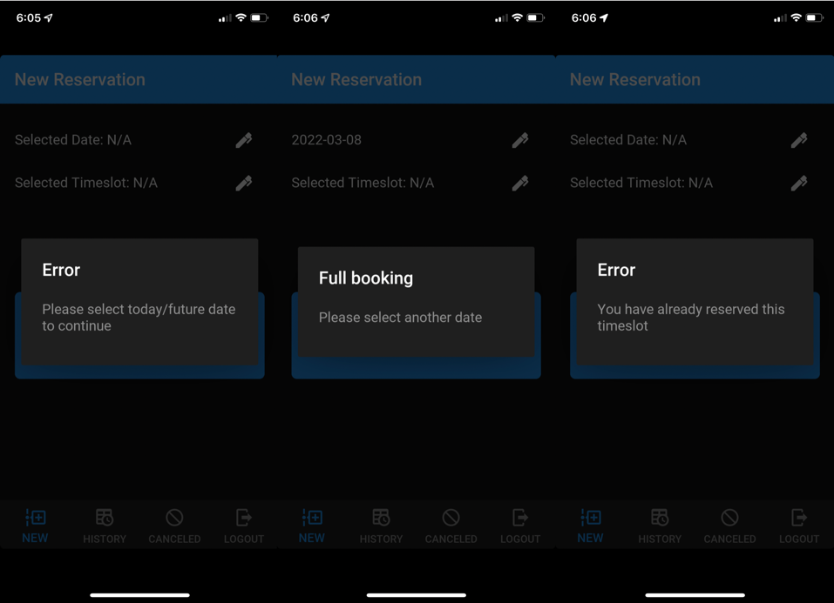

Fig. 28. Error messages of new reservation process

To make new reservation, user need to select both date and the time slot according to the process shown in Fig 28. Error messages will be shown if the date selected is not the existing date or future date or the booking of that day is full. In addition, if users have already made an appointment on the time slot, an error message will be shown to remind user. Otherwise, the success message will be shown.

## **3.3 Reservation Record and Cancel Reservation**

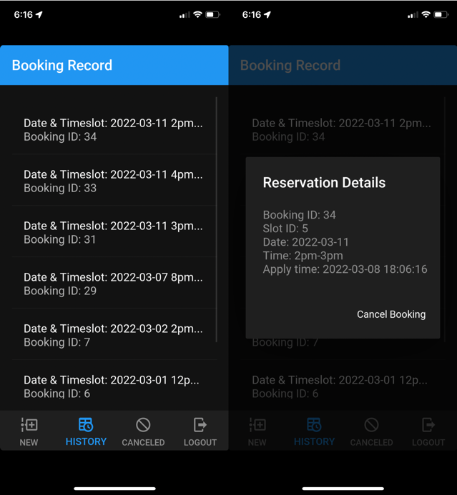

Fig. 29. Screenshots of booking record page

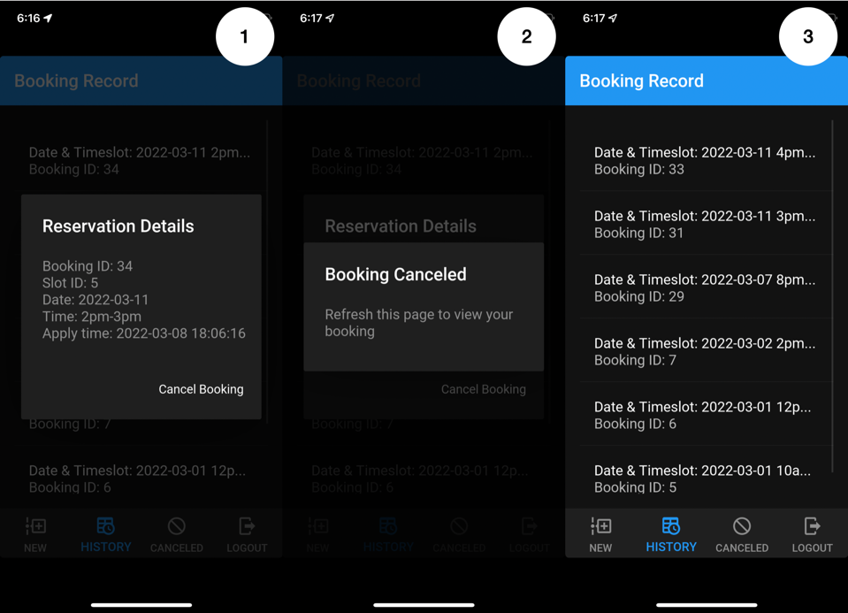

Fig. 30. Cancel reservation process

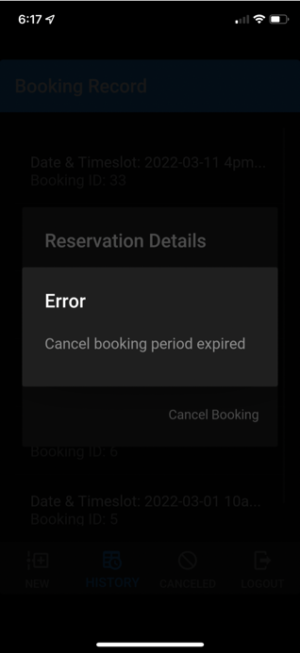

Fig. 31. Error messages of cancel reservation process

As shown in Fig 29, the reservation record can be view easily by simply open the History tab, listing all the record according to the Booking ID in descending order. Meanwhile, by clicking a record, additional details including Slot ID and Apply time will be shown.

In addition, by clicking the Cancel Booking button, users can cancel the reservation easily and users can check the cancelled reservation in Cancelled tab. If the cancel reservation period expired, which ends on the day of reservation, an error message like Fig 31 will be shown.

## **3.4 Cancelled Reservation Record**

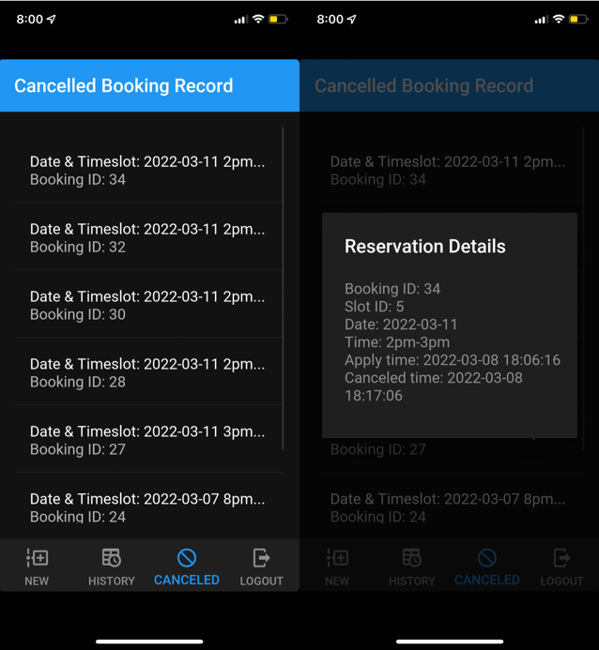

Fig. 32. Screenshots of cancelled booking record page

The cancelled reservation record list all the cancelled reservation with additional details of Cancelled time.

## **3.5 Log Out**

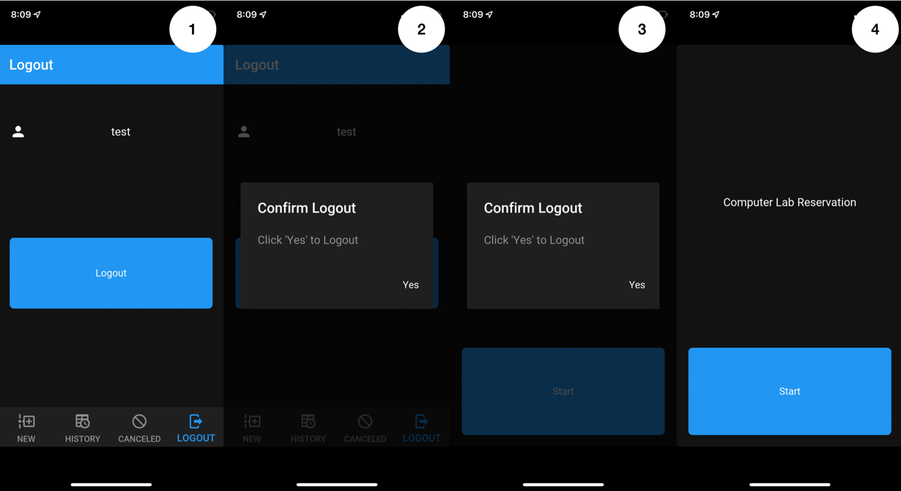

Fig. 33. Log out process

By double confirming the log out button shown in Fig. 33, users will logout the system and the start page will be shown.

# **Testing**

## **4.1 Test Plan**

|  |  |
| --- | --- |
| Test case | Objective |
| Test 01  Log in | Test if the system can handle valid/ invalid username, password, first character of the TCP URL, and TCP port number |
| Test 02  Select reservation date | Test if the system cam display the selected date on the screen |
| Test 03  Select reservation time slot | Test if the system can use the selected date to found and display the available time slot from the database |
| Test 04  Apply reservation | Test if the system can upload the new reservation record to database and handle the invalid reservation |
| Test 05  View reservation | Test if the system can list all the reservation record |
| Test 06  Cancel reservation | Test if the system can update the database for cancelling the reservation |
| Test 07  View cancelled reservation | Test if the system can list all the cancelled reservation record |
| Test 08  Log out | Test if the use can log out the system |

## **4.2 Test Cases**

|  |  |
| --- | --- |
| Test 01 | Log in |

|  |  |  |  |  |
| --- | --- | --- | --- | --- |
| Steps | Action | Test data | Expected result | Pass/fail |
| 1 | Input valid username, valid password, valid first character of the TCP URL and valid TCP port number | test, test, 2, 13806 | Main page shown | Pass |
| 2 | Input invalid username, valid password, valid first character of the TCP URL and valid TCP port number | testest, test, 2, 13806 | Error message “Login failed” shown on screen | Pass |
| 3 | Input valid username, invalid password, valid first character of the TCP URL and valid TCP port number | test, testest, 2, 13806 | Error message “Login failed” shown on screen | Pass |
| 4 | Input invalid username, invalid password, valid first character of the TCP URL and valid TCP port number | testest, testest, 2, 13806 | Error message “Login failed” shown on screen | Pass |
| 5 | Input empty username, empty password, valid first character of the TCP URL and valid TCP port number | ‘’, ‘’, 2, 13806 | Error message “Error” shown on screen | Pass |
| 6 | Input valid username, valid password, invalid first character of the TCP URL and valid TCP port number | test, test, 2, 13806 | Error message “Cannot connect server” shown on screen | Pass |
| 7 | Input valid username, valid password, valid first character of the TCP URL and invalid TCP port number | test, test, 2, 11177 | Main page not shown as port number is invalid | Pass |
| 8 | Input valid username, valid password, invalid first character of the TCP URL and invalid TCP port number | test, test, 4, 11177 | Main page not shown as both first character of the TCP URL and port number are invalid | Pass |
| 9 | Input valid username, valid password, empty first character of the TCP URL and empty TCP port number | test, test, ’’, ’’ | Error message “Cannot connect server” shown on screen | Pass |
| 10 | Input empty username, empty password, empty first character of the TCP URL and empty TCP port number | ‘’, ‘’, ’’, ’’ | Error message “Error” shown on screen | Pass |

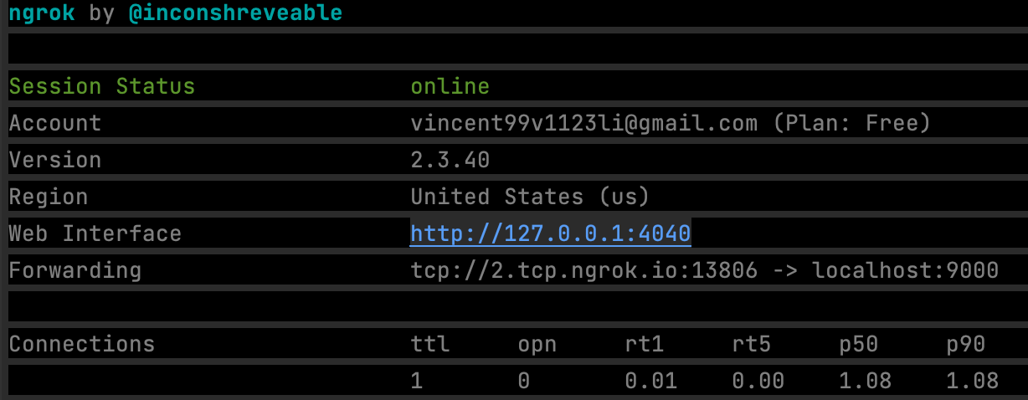

Fig. 34. Terminal screen when connecting to ngrok during Test 01

|  |  |
| --- | --- |
| Test 02 | Select reservation date |

|  |  |  |  |  |
| --- | --- | --- | --- | --- |
| Steps | Action | Test data | Expected result | Pass/fail |
| 1 | Select today’s date | 2022-03-12 | Date can be selected by user and shown on screen | Pass |
| 2 | Select yesterday’s date | 2022-03-11 | Error message “Error” shown on screen | Pass |
| 3 | Select tomorrow’s date | 2022-03-13 | Date can be selected by user and shown on screen | Pass |
| 4 | Select a random date before today | 2021-12-21 | Error message “Error” shown on screen | Pass |
| 5 | Select a random date before today 2 | 2020-02-29 | Error message “Error” shown on screen | Pass |
| 6 | Select a random date after today | 2022-08-04 | Date can be selected by user and shown on shown on screen | Pass |
| 7 | Select a random date after today 2 | 2023-01-02 | Date can be selected by user and shown on screen | Pass |

|  |  |
| --- | --- |
| Test 03 | Select reservation time slot |

|  |  |  |  |  |
| --- | --- | --- | --- | --- |
| Steps | Action | Test data | Expected result | Pass/fail |
| 1.1 | Input selected valid date (today/ future date) with available time slot in database where vacancy > 0 | 2022-08-04 | List of time slots of the selected date are displayed if vacancy > 0 | Pass |
| 1.2 | Selected one of the listed time slot option | 2pm-3pm | Time slot can be selected by user and shown on screen with its slot_id | Pass |
| 2 | Input selected valid date with available time slot in database where vacancy =0 | 2022-03-13 | Error message “Full booking” shown on screen | Pass |
| 3 | Input selected valid date with no available time slot in database | 2022-03-14 | Error message “Full booking” shown on screen | Pass |

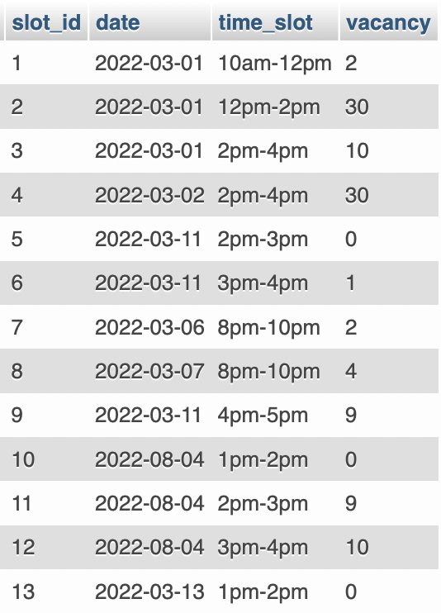

Fig. 35. Screenshot of database with all available time slots (Timeslot table)

|  |  |
| --- | --- |
| Test 04 | Apply reservation |

|  |  |  |  |  |
| --- | --- | --- | --- | --- |
| Steps | Action | Test data | Expected result | Pass/fail |
| 1 | Click “Confirm” to apply for the reservation | 2022-08-04, 2pm-3pm | Message “Success” shown on screen, vacancy in database -1 (Fig. 36), record uploaded to database | Pass |
| 2 | Click “Confirm” with the same test data to apply for the reservation | 2022-08-04, 2pm-3pm | Message “Error, you have already reserved” shown on screen | Pass |
| 3 | Click “Confirm” with only date are selected | 2022-08-04, ‘’ | Message “Error, please selected date and timeslot” shown on screen | Pass |
| 4 | Click “Confirm” with neither date nor time slot selected | ‘’, ‘’ | Message “Error, please selected date and timeslot” shown on screen | Pass |

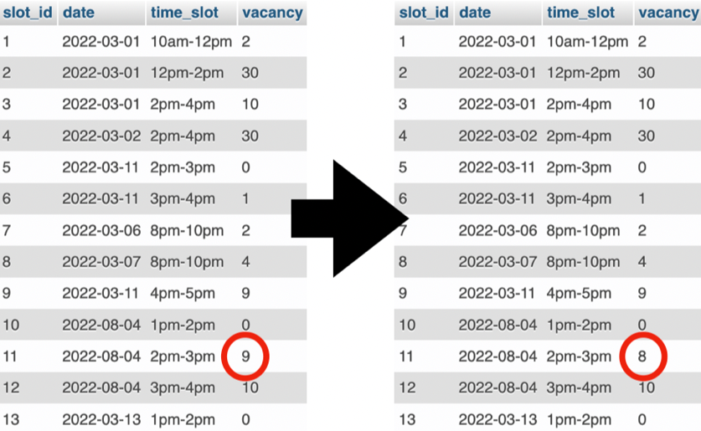

Fig. 36. Change of vacancy in database

|  |  |
| --- | --- |
| Test 05 | View reservation |

|  |  |  |  |  |
| --- | --- | --- | --- | --- |
| Steps | Action | Test data | Expected result | Pass/fail |
| 1.1 | View “History” tab with user account who have made reservation before & at least 1 reservation not cancelled | Username: test | All non-cancelled reservation listed according to booking_id in descending order | Pass |
| 1.2 | Click a random record list shown in last step | Booking ID: 31 | The details of reservation shown, including booking_id, slot_id, date, time_slot and apply_date_time | Pass |
| 2 | View “History” tab with user account who have not made reservation before | Username: test3 | Empty list shown | Pass |

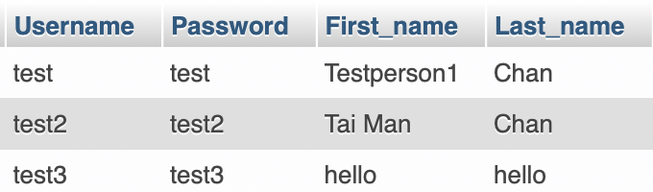

Fig. 37. Screenshot of database with all users (User table)

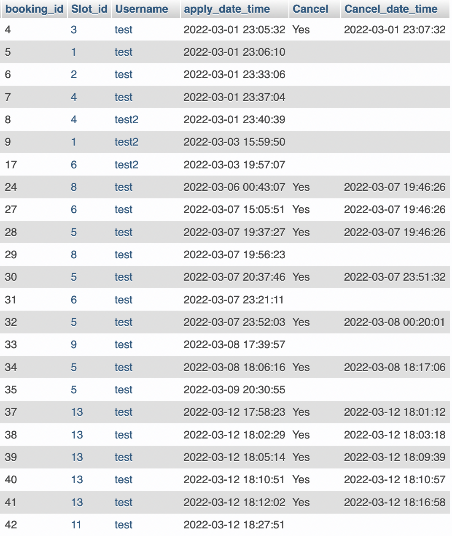

Fig. 38. Screenshot of database with all reservations (Booking table)

|  |  |
| --- | --- |
| Test 06 | Cancel reservation |

|  |  |  |  |  |
| --- | --- | --- | --- | --- |
| Steps | Action | Test data | Expected result | Pass/fail |
| 1 | Select a valid record (future date) to be deleted | 2022-08-04 2pm-3pm | Message “Booking Cancelled” shown, vacancy in database updated, Cancel indicator and Cancel_date_time inserted to database (Fig. 39) | Pass |
| 2 | Select a invalid record (past date/ today’s date) to be deleted | 2022-03-11 2pm-3pm | Error message shown | Pass |

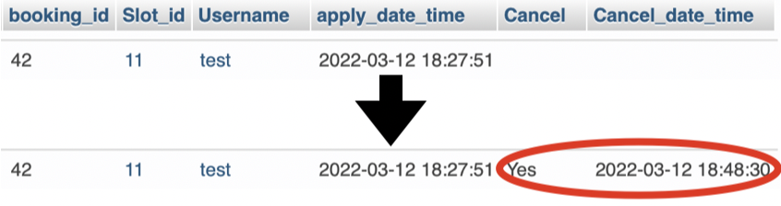

Fig. 39. Reservation record of database updated by inserting the Cancel indicator and Cancel_date_time

|  |  |
| --- | --- |
| Test 07 | View cancelled reservation |

|  |  |  |  |  |
| --- | --- | --- | --- | --- |
| Steps | Action | Test data | Expected result | Pass/fail |
| 1.1 | View “Canceled” tab with user account who have cancelled at least 1 reservation | Username: test | All cancelled reservation listed according to booking_id in descending order | Pass |
| 1.2 | Click a random record list shown in last step | Booking ID: 30 | The details of reservation shown, including booking_id, slot_id, date, time_slot, apply_date_time and Cancel_date_time | Pass |
| 2 | View “Canceled” tab with user account who have not canceled reservation before | Username: test3 | Empty list shown | Pass |

|  |  |
| --- | --- |
| Test 08 | Log out |

|  |  |  |  |  |
| --- | --- | --- | --- | --- |
| Steps | Action | Test data | Expected result | Pass/fail |
| 1 | Click Logout | / | Start page shown | Pass |

# **Limitation and Further Development**

Although the system successfully fulfil the objective of offering a platform the students to make, view and cancel reservation of the computer lab anytime and anywhere, there could be improvement to further convenience the students and staff.

1. A separate system managing app could be developed for the staff convenience. Currently, the only method for the staff to view and manage all the timeslot available is to access the database management system (DBMS) directly, which is phpMyAdmin in our case. For instance, to add new timeslot options, the staff are requiring adding new record to database like Fig. 40. As the date and time are set as varchar, the input of the field is a textbox which increase the chance of typographical error. By having separate app similar to the reservation app, an easy-to-use date or time picker can be created for staff while maintaining the connection to database. In addition, same as the reservation app, the system managing app can allow the staff to manage the reservation anytime and anywhere with a much simpler UI compared to phpMyAdmin which includes many irrelevant features for most of the staff.
2. A database of recording all computer labs and all computers in each lab could be introduced. Currently, the system only set the number vacancy of each time slot without linking the vacancy to the available computer labs and computer. By introducing the record of computer labs and computers in each lab, a much-detailed reservation could be introduced by assign rooms and number of computers to reservation, which offers more information for management and tracing for specific students when incident.

On the other hand, although Python with Kivy library is able to build cross-platform apps and all the features of this assignment could be implemented successfully, the possibility of developing other applications are limited when supporting iOS environment. For example, the screen size of app cannot adapt the screen size recent iOS device with face ID, leaving the top and bottom screen unused by the app, wasting the area to display more information. Furthermore, there are difficulties on accessing the API in iOS including files, photos, camera on the phone, limiting the functionality and possibility on app development.

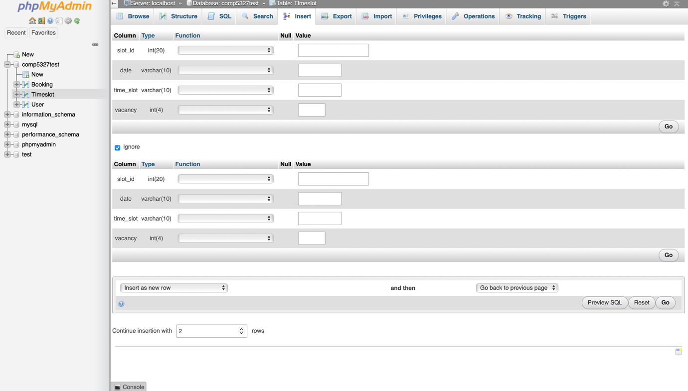

Fig. 40. Record insert screen of phpMyAdmin

# **Program Files**

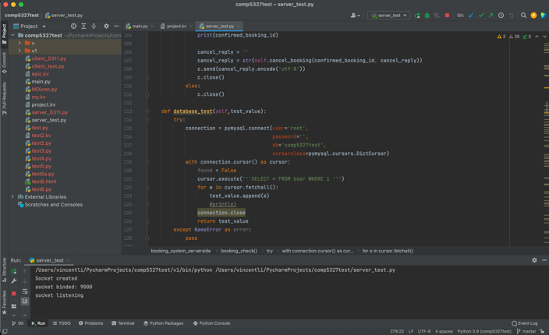

Fig. 41. Screenshot of PyChacm IDE (server_test.py)

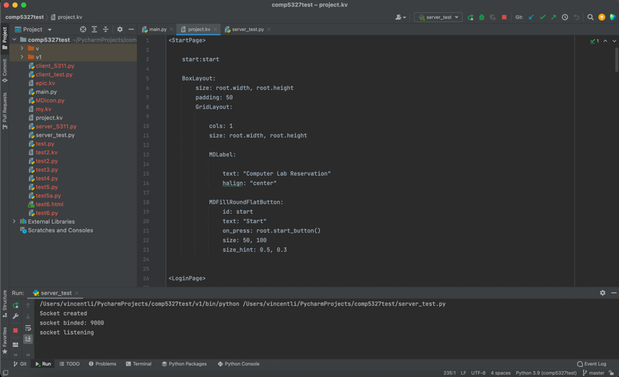

Fig. 42. Screenshot of PyCharm IDE (project.kv)

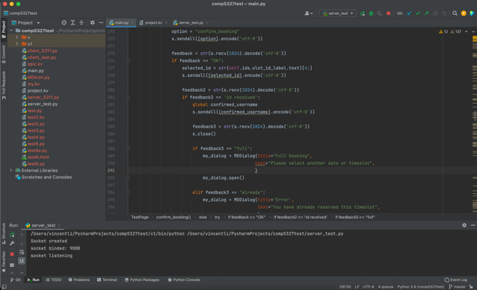

Fig. 43. Screenshot of PyChacm IDE (main.py)

The code of the project can be downloaded from GitHub (<https://github.com/vincennt99v1123li/comp5327test.git>), which includes 4 files:

* main.py – the reservation app Python file
* project.kv – UI of the reservation app coded by Kivy language
* server_test.py – server-side program Python file
* comp5327test.sql – database of the server-side program

By downloading all files from GitHub to Windows/ Mac computer with all packages listed on Section 2.2 of this reported installed, both python programs could be run locally on Windows/ Mac environment.

# **Conclusion**

In this project, the school computer lab reservation app was successfully developed to convince students. The system can be even mature by adding function to modify the database without touching the DBMS or assign sitting students automatically.

On the other hand, by using Python with Kivy framework, apps are able to be ported on multiple platforms easily without modification on program codes. Although this convenience, Python with Kivy framework may not be the most suitable programming language for developing mobile apps especially on iOS due to the limitation on accessing API on the system like photo stored in the phone. Choosing the right programming language or tools to achieve the objectives of mobile application is always an important step and consideration during development.

# **References**

|  |  |
| --- | --- |
| [1] | Kivy, *Kivy - Open source Python library for rapid development of applications*  *that make use of innovative user interfaces, such as multi-touch apps*, n.d. [Online]. Available: https://kivy.org/#home [Accessed Feb. 17, 2022]. |
| [2] | A. Rodríguez, I. Yuri, A. Bulgakov, and KivyMD contributors, *Welcome to KivyMD’s documentation!*, 2021. [Online]. Available: https://kivymd.readthedocs.io/en/latest/ [Accessed Feb. 25, 2022]. |
| [3] | VMware, *XAMPP Apache + MariaDB + PHP + Perl,* 2022. [Online]. Available: https://www.apachefriends.org/index.html [Accessed Feb. 26, 2022]. |
| [4] | Ngrok, *What is ngrok?*, 2022. [Online]. Available: https://ngrok.com/product [Accessed Feb. 22, 2022]. |
| [5] | Ngrok, *Documentation*, n.d. [Online]. Available: https://ngrok.com/product [Accessed Feb. 22, 2022]. |
| [6] | Free Software Foundation, Inc., *Autoconf*, 2020. [Online]. Available: https://www.gnu.org/software/autoconf/ [Accessed Feb. 20, 2022] |
| [7] | Cyton, *About Cython*, n.d. [Online]. Available: https://cython.org [Accessed Feb. 20, 2022] |
| [8] | Kivy, *Programming Guide » Create a package for iOS*, n.d. [Online]. Available: https://kivy.org/doc/stable/guide/packaging-ios.html [Accessed Feb. 20, 2022] |
| [9] | Kivy, *Kivy for iOS*, 2022. [Online]. Available: https://github.com/kivy/kivy-ios [Accessed Feb. 20, 2022] |
| [10] | PeanutTheAdmin, *Getting Started with Kivy-ios | Setup | Walkthrough | Intro | for MacOSX*, Jun 30, 2021. [Video file]. Available: https://www.youtube.com/watch?v=6gLGyrlgqCU [Accessed Feb. 20, 2022] |